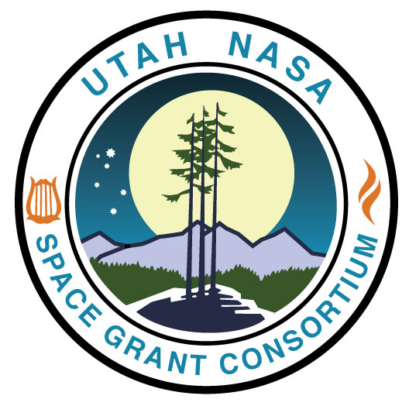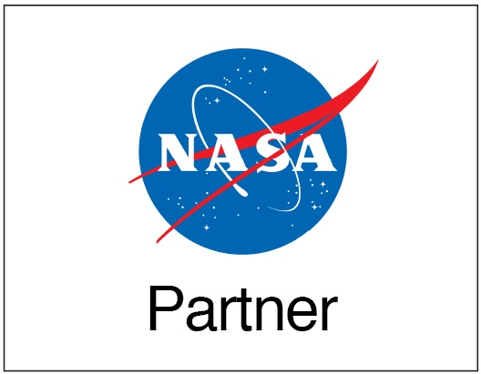
2023-24 UTAH NASA SPACE GRANT CONSORTIUM
SCHOLARSHIP OPPORTUNITY at USU

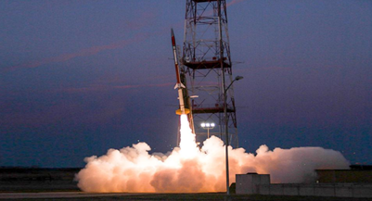
Background and Scholarship Information: A primary objective of NASA’s Space Grant Program is to recruit, train, and employ U.S. citizens, especially women and underrepresented groups, in NASA-related careers. The Utah NASA Space Grant Consortium (UNSGC) will award one-year scholarships for $1,000 each during the current academic year: 2023-24. Awardees may re-apply for the following year upon satisfactory progress toward their undergraduate STEM degree and if the student is still enrolled full-time.

Criteria to Apply:
- Must be a U.S. Citizen as required by NASA.
- Must be registered as a full-time undergraduate student (12 credit hours or more) at USU.
- Must be majoring in a STEM field of study (Science, Technology, Engineering, and Mathematics).

Preference:
- Preference for this scholarship shall be given to students from underrepresented groups.
- Preference shall be given to students who demonstrate a commitment to Latine/x, AmericanIndian/Native/Indigenous or Alaska Native, Black or African Diaspora, Native Hawaiian/Other Pacific Islander communities through their leadership and engagement.
- Preference will be given to women majoring in a STEM field (Science, Technology, Engineering, and Mathematics).

Application Timeline:
- Announced: October 4th
- Closes: November 1st
- Review Begins: November 6th
- Awards Announced: November 15th

Documents for Application:
- Unofficial Transcript
- Utah NASA Space Grant Application Form
- Essay Questions

If you meet the criteria and would like to apply for this scholarship, please complete the application form as well as the required essay questions. Submit the application form, essay questions, and unofficial transcript to kim.olson@usu.edu by November 1, 2023. This application package can be found on our website at: http://www.utahspacegrant.com/for-students/.

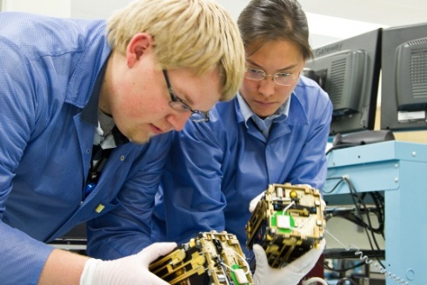
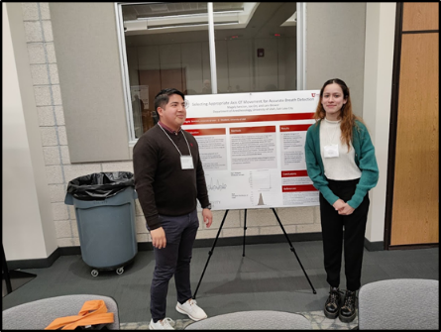
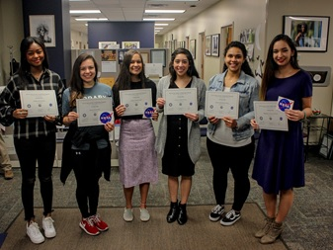

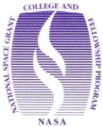
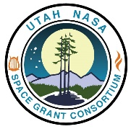
2023-24 UTAH NASA SPACE GRANT CONSORTIUM
STEM STUDENT SCHOLARSHIP OPPORTUNITY AT USU
Full Name
First / Middle / Last
Birthdate
MM/DD/YYYY
Student A Number
E-mail address (Primary)  E-mail address (Secondary)  Please be sure to list both | One school/university/college email plus a personal email so we can reach you in the future
Phone Number

Gender

Ethnicity (please mark one) | Hispanic or Latino? ____ yes ____ no
Racial category  (please mark one or more) | ____ American Indian or Alaska Native ___ Asian ___ White  ____ Black or African American ____ Native Hawaiian/Other Pacific Islander
Disability?  (please mark one or more) | ____ Hearing impairment ___ Visual impairment ___ Mental impairment  ___Mobility/Orthopedic impairment ___ Do not wish to provide ___ None  ___Other (please specify): _____________________
United States Citizen?
(yes or no)
Current address
Street / City / State / Zip

Permanent address
Street / City / State / Zip

Enrolled major
(Dept. & College)
Academic Status
(Fresh, Soph, Jr, Sr)
Number of Credit Hours Enrolled
Anticipated semester of graduation
Current GPA

Faculty Mentor/Advisor name and email address
Are you a first-generation college student? (Will you or your siblings be the first in your family to graduate college?) (yes or no)
Longitudinal Tracking: Longitudinal tracking of all direct student awards is a requirement of the NASA Space Grant program. | ______ Please initial here if you agree to respond to quarterly email requests to update your status with current education and/or employment information.

APPLICATION FORM

ALL APPLICANTS: Please respond to the following essay questions.
(500-word limit per question)

- Why did you select a STEM field of study and how do you feel that your academic and career goals contribute to NASA’s mission and work in exploration and discovery?

- Preference shall be given to students who demonstrate a commitment to the Latinx, Black/African Disapora, American Indian/Native/Indigenous and/or Pacific Island community through engagement or leadership. How will you use your current STEM degree to impact these communities?

- Describe any past outreach or mentoring activities that you have undertaken, especially those that are STEM-related. Also, list any involvement with student clubs on campus or research/work experience in your STEM field.

APPLICANTS WHO HAVE RECEIVED THE SCHOLARSHIP IN THE PAST AND ARE RE-APPLYING: Please also respond to this question in addition to the three questions above.

- How do your academic interests relate to the NASA vision and substantively align with one or more of the NASA Mission Directorates? See attached Appendix A. Agency Information and Strategic Framework. For a detailed description of NASA’s mission, history, and future plans, visit the following NASA website: http://www.nasa.gov/about/highlights/what_does_nasa_do.html

APPENDIX A: AGENCY INFORMATION AND STRATEGIC FRAMEWORK
NASA’s current topics and relevant missions are listed below. (For use with essay question #4 if applicable.)

Humans in Space
International Space Station (ISS) - Commercial Crew Program (CCP) - NASA Astronauts - Low Earth Orbit (LEO) Economy

Moon to Mars
Commercial Lunar Payload Series (CLPS) Initiative - Lunar Gateway - Artemis Mission - Space Launch System (SLS)

Earth
Air – Climate - Hazards - Water, Oceans, and Ice - Land

Space Tech
Space Travel - Living in Space - Manufacturing, Materials, and 3-D Printing - Robotics - Science Instruments - High-Tech Computing

Flight
Green Aviation - Future Aircraft - Supersonic Flight - Reducing Flight Delays - Unmanned Aircraft

Solar System and Beyond
Planets, Moons, and Dwarf Planets - The Search for Life and Exoplanets - The Sun - Stars and Galaxies - Black Holes - Dark Energy and Dark Matter

Current High-Profile NASA Missions
• Artemis Program
• Commercial Crew Program
• Curiosity Mars Rover
• Hubble Space Telescope
• InSight Mars Lander
• International Space Station
• James Webb Space Telescope
• Juno: Mission of Jupiter
• Lunar Reconnaissance Orbiter
• Mars Perseverance Rover
• New Horizons: Pluto and Beyond
• OSIRIS-Rex Asteroid Mission
• Parker Solar Probe

NASA Vision: To explore the secrets of the universe for the benefit of all.

NASA Mission: Lead an innovative and sustainable program of exploration with commercial and international partners to enable human expansion across the solar system and bring new knowledge and opportunities back to Earth. Support growth of the Nation’s economy in space and aeronautics, increase understanding of the universe and our place in it, work with industry to improve America’s aerospace technologies, and advance American leadership.

Strategic themes that make up the foundation of the 2018 Strategic Plan and NASA’s goals
• DISCOVER - Expand human knowledge through new scientific discoveries
• EXPLORE - Extend human presence deeper into space and to the Moon for sustainable long-term exploration and utilization
• DEVELOP - Address national challenges and catalyze economic growth
• ENABLE – Optimize capabilities and operations

NASA’s vision and mission draw support from the organizational structure of the Mission Directorates, each with a specific responsibility.

NASA’s Mission Directorates
• Aeronautics Research Mission Directorate (ARMD): transforms aviation with research to dramatically reduce the environmental impact of flight, and improves aircraft and operations efficiency while maintaining safety in increasingly crowded skies. ARMD also generates innovative aviation concepts, tools, and technologies for development and maturation by the aviation community. https://www.nasa.gov/aeroresearch

• Exploration Systems Development Mission Directorate (ESDMD): defines and manages systems development for programs critical to the NASA’s Artemis program and planning for NASA’s Moon to Mars exploration approach in an integrated manner. ESDMD manages the human exploration system development for lunar orbital, lunar surface, and Mars exploration. ESDMD leads the human aspects of the Artemis activities as well as the integration of science into the human system elements. ESDMD is responsible for development of the lunar and Mars architectures. Programs in the mission directorate include Orion, Space Launch System, Exploration Ground Systems, Gateway, Human Landing System, and Extravehicular Activity (xEVA) and Human Surface Mobility. https://www.nasa.gov/directorates/exploration-systems-development

• Science Mission Directorate (SMD): expands the frontiers of Earth science, heliophysics, planetary science, and astrophysics. Using robotic observatories, explorer craft, ground-based instruments, and a peer-reviewed portfolio of sponsored research, SMD seeks knowledge about our solar system, the farthest reaches of space and time, and our changing Earth. http://science.nasa.gov/

• Space Operations Mission Directorate (SOMD): manages NASA’s current and future space operations in and beyond low-Earth orbit (LEO), including commercial launch services to the International Space Station. SOMD operates and maintains exploration systems, develops and operates space transportation systems, and performs broad scientific research on orbit. In addition, SOMD is responsible for managing the space transportation services for NASA and NASA-sponsored payloads that require orbital launch, and the agency's space communications and navigation services supporting all NASA’s space systems currently in orbit. https://www.nasa.gov/directorates/space-operations-mission-directorate

• Space Technology Mission Directorate (STMD): pursues transformational technologies that have high potential for offsetting future mission risk, reducing cost, and advancing existing capabilities. STMD uses merit-based competition to conduct research and technology development, demonstration, and infusion of these technologies into NASA’s missions and American industry. This mission directorate is being refocused as a new Exploration Research & Technology (ER&T) organization to support exploration as a primary customer. http://www.nasa.gov/directorates/spacetech/home/index.html

• The Mission Support Directorate (MSD): enables the Agency’s missions by managing institutional services and capabilities. MSD is actively reducing institutional risk to NASA’s current and future missions by improving processes, stimulating efficiency, and providing consistency and uniformity across institutional standards and practices. https://www.nasa.gov/msd

